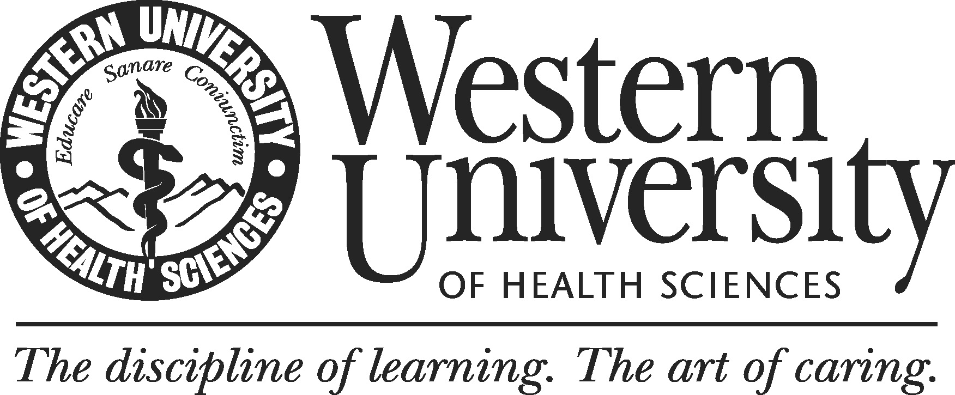
Guidelines for External Review

Overview

An important component of WesternU’s Program Review process, the external review team is responsible for providing honest, unbiased professional feedback on program quality.

Responsibilities include:

1. Reviewing the program’s self‐study document and any accompanying appendices

2. Engaging in additional information-gathering activities, including identifying and meeting with the program review self-study committee and other members of the program under review to substantiate the validity of findings in self-study report. The reviewers may request additional documents or they may request to visit facilities and other relevant campus sites and constituencies.

3. Debriefing program leads and program members to discuss preliminary findings.

4. Preparing a formal report that assesses program quality, identifies strengths and weaknesses, and makes recommendations for improvements.

The external team will consist of 2-3 individuals selected by Director of Institutional Research and Effectiveness at WesternU, in consultation with program leads. The team report should contain realistic, attainable recommendations that can be addressed by the program during a given timeframe. The report should distinguish between recommendations that might be accomplished given current resources and those that may require additional investment in the program.

Guidelines for Reviewer feedback

I. GENERAL OBSERVATIONS
- Please comment on the quality of the report
  - Are findings adequately supported by evidence?
  - Does the program use appropriate benchmarks to assess its findings?

II. MISSION
- Is the program’s mission appropriate to the field?
- Are there plans in place to achieve and assess mission fulfillment?

III. STUDENT LEARNING OUTCOME
- Does the program provide evidence that demonstrate achievement of student learning outcomes?
- Are outcome metrics evaluated to assess program effectiveness and to inform program improvement efforts?

IV. CURRICULUM
- Is the curriculum content well organized, appropriate, and includes generally accepted experiences for the degree?
- Does the curriculum align stated learning outcomes?

V. FACULTY
- Is the program adequately staffed and qualified to fulfill the mission and purpose?

VI. STUDENT BODY
- Does the program periodically review admission data?
- Is the data used to inform recruitment and curricular modifications?
- Do student academic support services ensure quality and facilitate the attainment of the program and University educational objectives?

VII. PHYSICAL FACILITIES
- Does the program have the necessary physical resources necessary (i.e, classroom space, research space, faculty and administrative offices, computers, instructional and information technologies, etc.) to carry out its goals?

VIII. STAFF
- Does the program have an adequate number of qualified staff to achieve its educational objectives?
IX. EXTERNAL ENVIRONMENT OF THE PROGRAM
- Does the program regularly review external developments outside that may impact their academic unit?

X. COMMENDATIONS AND RECOMMEDNATIONS
- Identify the program’s most significant strengths.
- Identify the program’s most significant weaknesses.
- Comment on the adequacy of the program’s self-identified plans for improvement.
- Identify any additional recommendations you have for the program other than those suggested in the self-study.

External Reviewer Timelines

Receive Self-study and Supporting Documents…………………….60 Days Prior to Site-visit

Site-visit

Program Debriefing………………………………………………....Within 2 Weeks of Site-visit

Submit Team Report to Program for
Corrections of Fact…………………………………………………..6 Weeks Post Site-visit

Submit Final Team Report to Program……………………………....8 Weeks Post Site-visit

